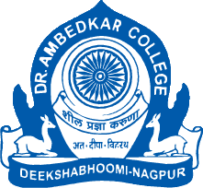
Parampoojya Dr. Babasaheb Smarak Samiti’s
Dr. Ambedkar College, Deekshabhoomi, Nagpur
Guest lecture on
International Criminal Law and Human Rights
Organized by
DEPARTMENT OF LAW
23rd December, 2022
Notice

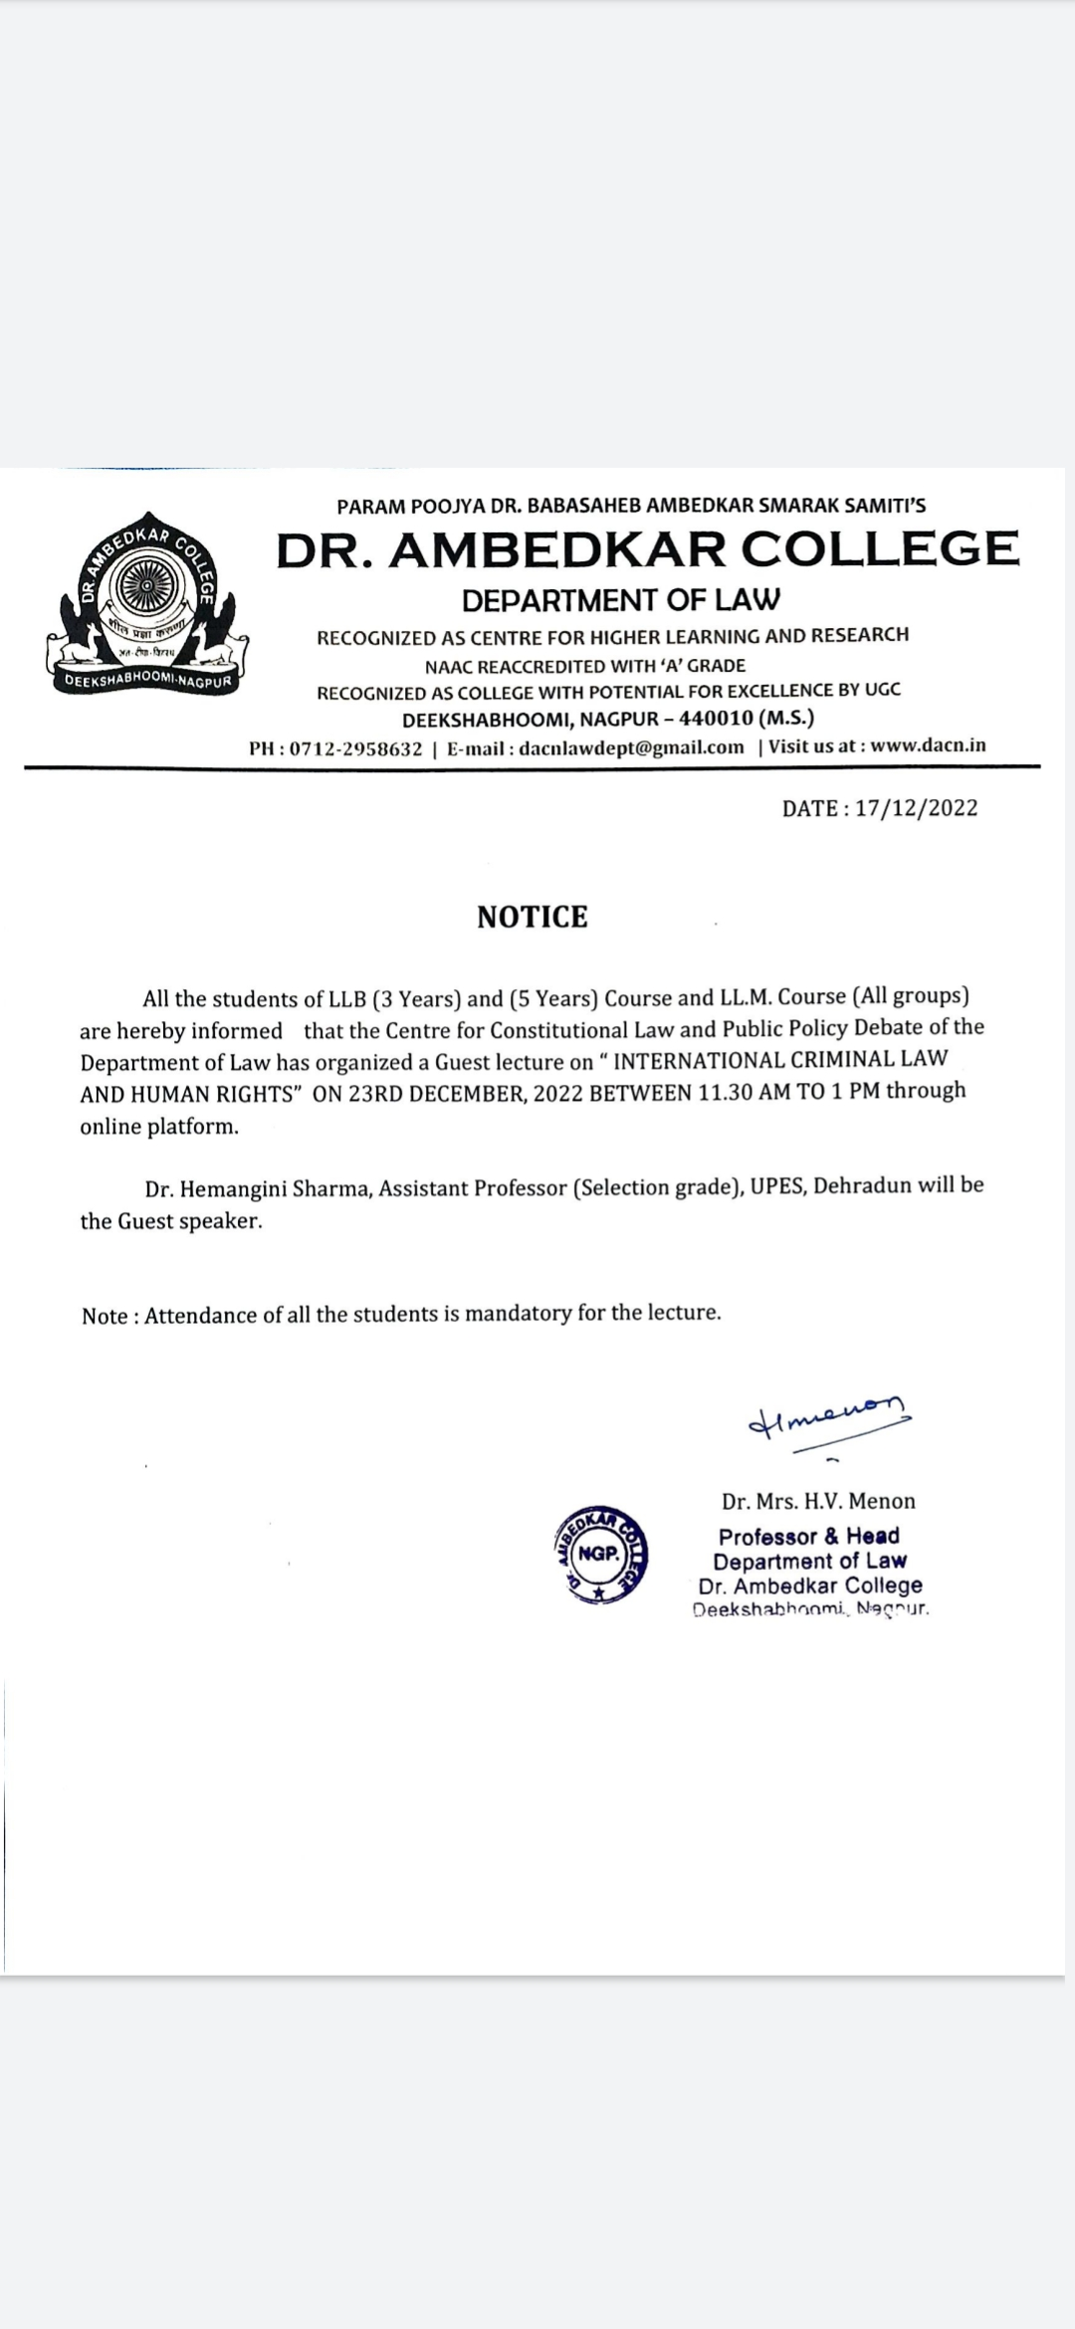

Report:
Dr. Ambedkar College, Department of Law, Deekshabhoomi, Nagpur, organized a Guest Lecture in online mode on “International Criminal Law and Human Rights”. The Resource person was Dr. Hemangini Sharma, Assistant Professor (Selection grade), UPES, Dehradun. The session started with the Introductory remarks of Dr. Varsha Deshpande, Co-ordinator, Centre for Constitutional Law and Public Policy debate of the Department.
The Speaker in this session discussed about the importance and purpose of International Criminal Law. She also discussed about the general principles involved in the International Criminal Law. Dr. Sharma also discussed about International Criminal court, its powers and functions. She also discussed the role played by International Criminal Law in protecting the human rights of individuals.
Her session was followed by Question- answer session. The proceeding of the session was conducted by Ms. Sneha Badiye, LLB student of the Department. The session was attended by approximately 70 participants including students of LLB and LL.M and the faculty members.

Photos:

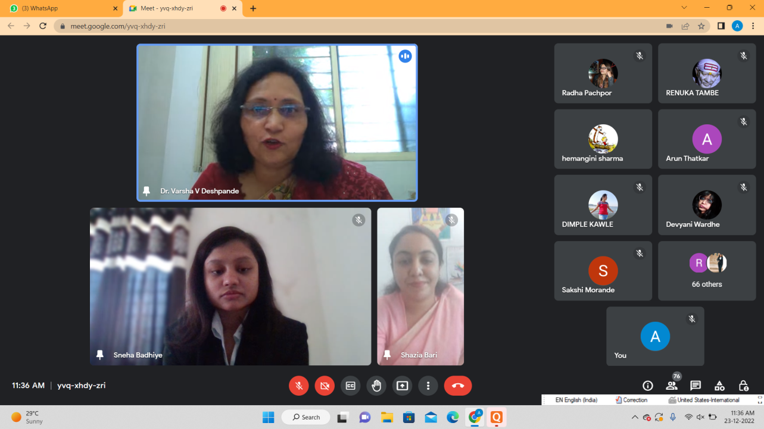
Dr. Varsha Deshpande, Co-ordinator of the Centre delivering Introductory remarks

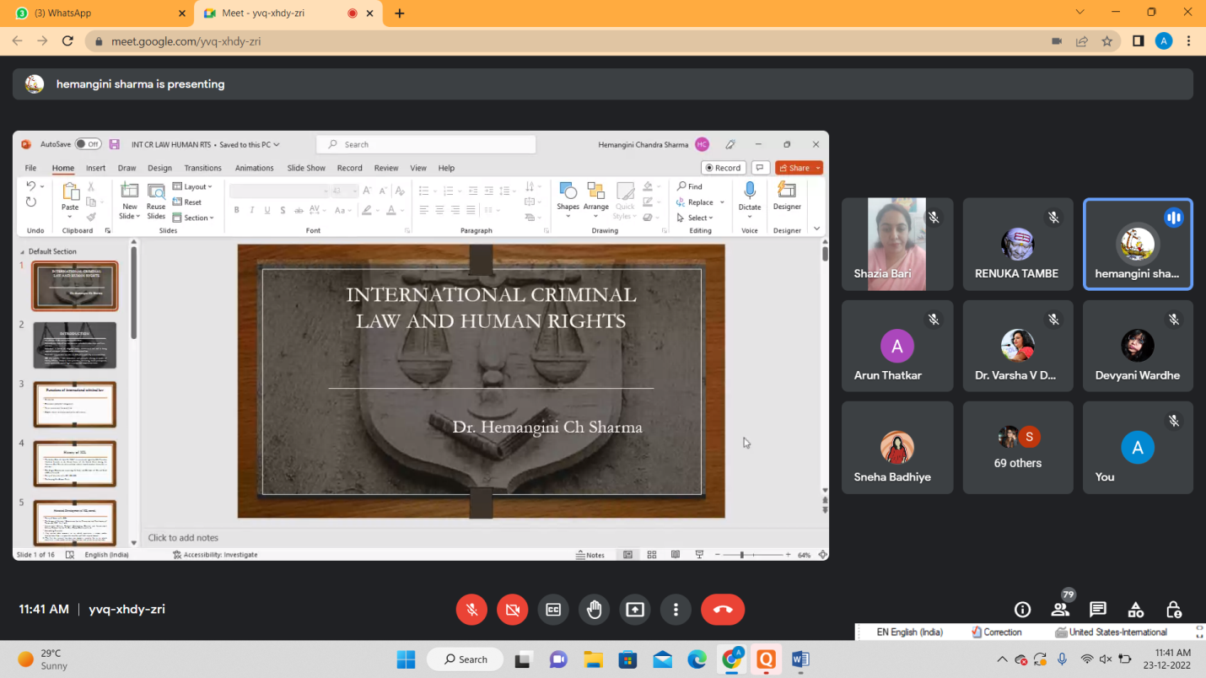
Dr. Hemangini Sharma addressing the participants
